META- AI LLM MODEL: GENERATIVE AI
1- Before we start, I want to use META-AI bot created by meta formerly we called as Facebook https://www.meta.ai/c/635ce50c-d872-40c0-8d7b-fd6d2d96a7c9
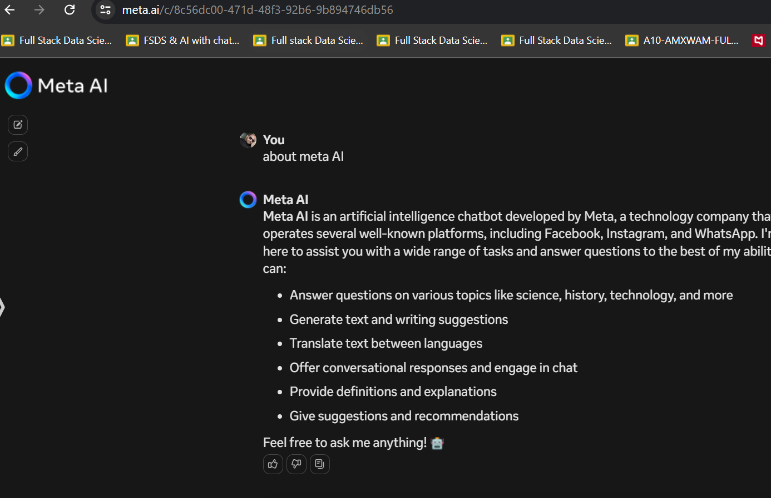
2-Google - type meta AI - click the 1st link or click the below link- https://ai.meta.com/meta-ai/
3- Click on meta llama Get started https://llama.meta.com/docs/get-started/
Read the left pane & download models
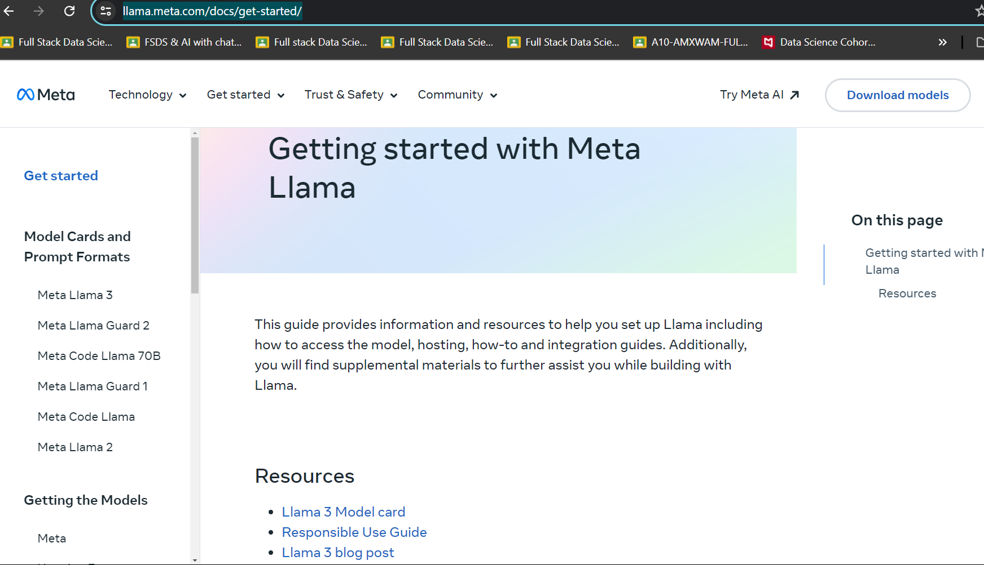
4- Explore every part of the website https://ai.meta.com/blog/meta-llama-3/
5- user can connect llama model to META, HUGGING FACE, KAGGLE & connect access
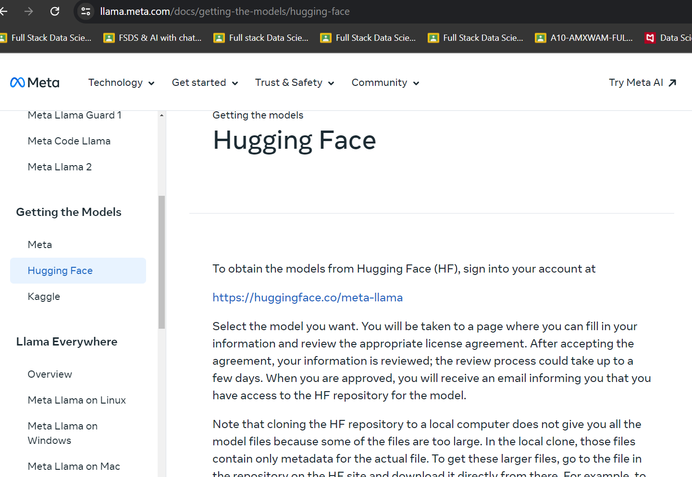
6- click on link It will open the hugging face web select meta llama -3 (8B) parameter
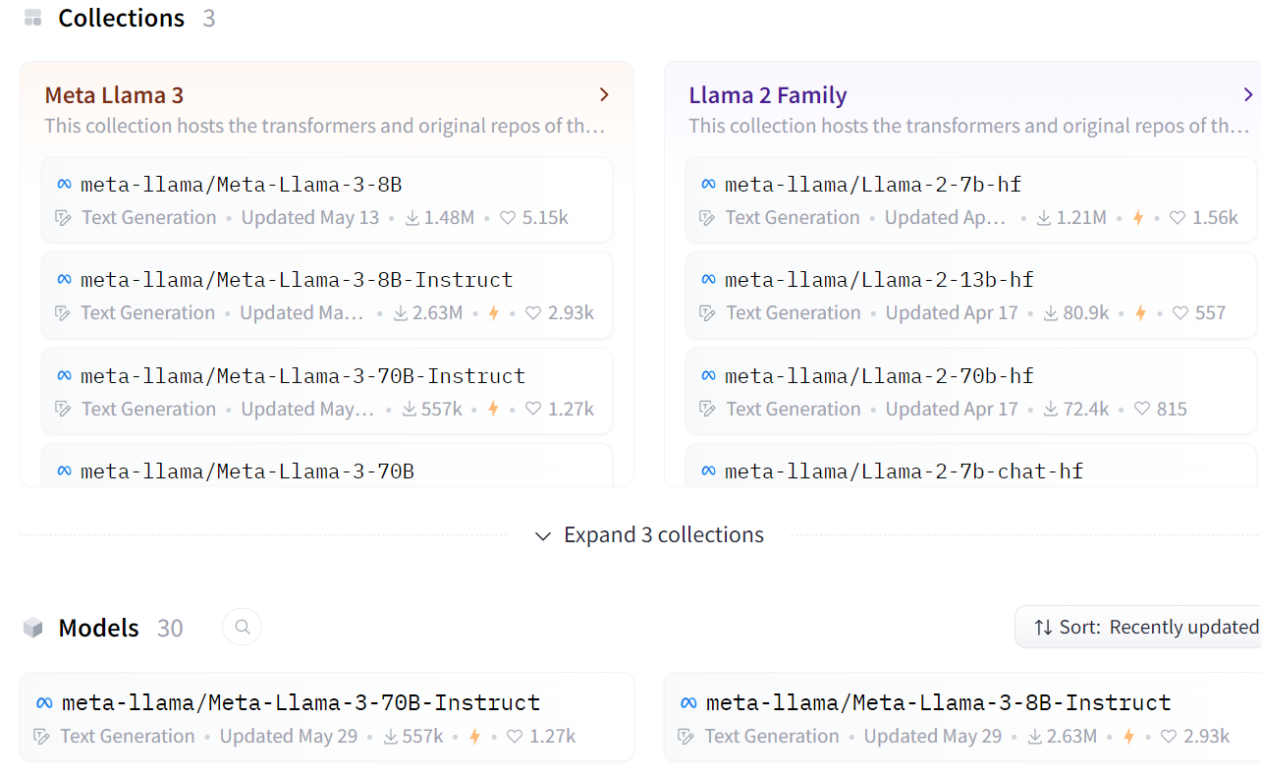
7- Also refer to meta AI GitHub page(setup instruction) https://github.com/meta-llama/llama3
WE UNDERSTAND META INTRODUCTION NOW
8- Google Type Hugging Face.com Create your login account verify the Gmail after that below page will appear user need to fill with detail information
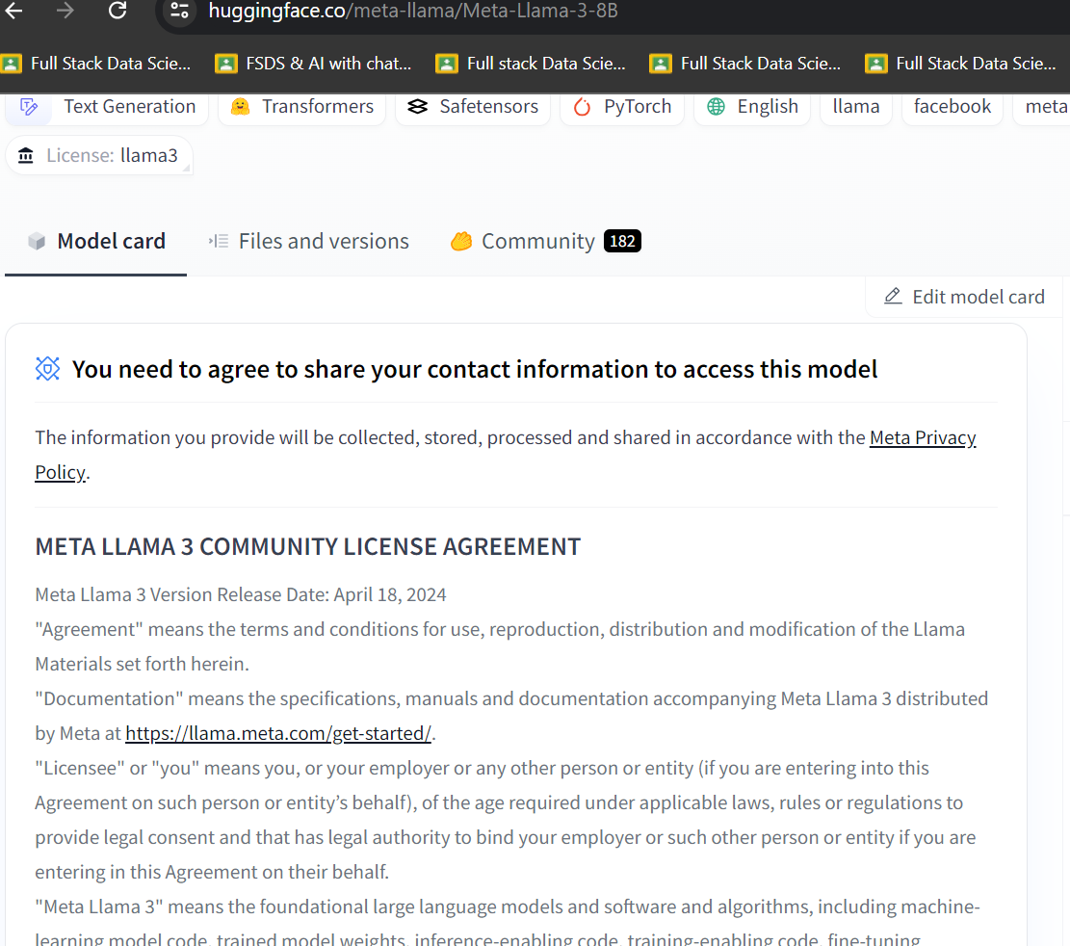
9- once the user fill the form then below message will appear saying - request access has submitted & awaiting for review Need to wait for sometime for gates repo status
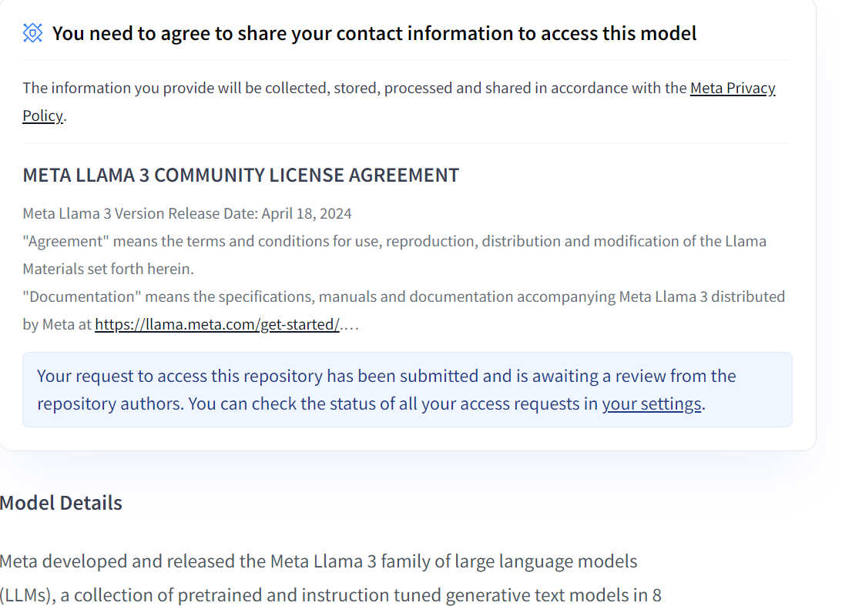
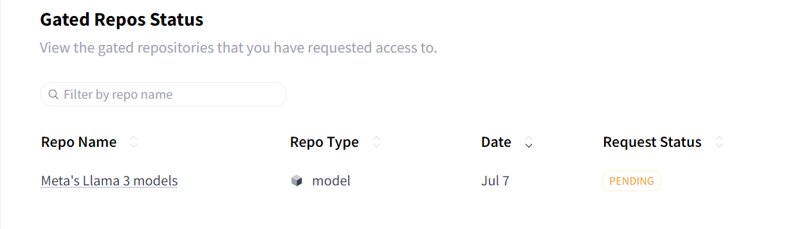
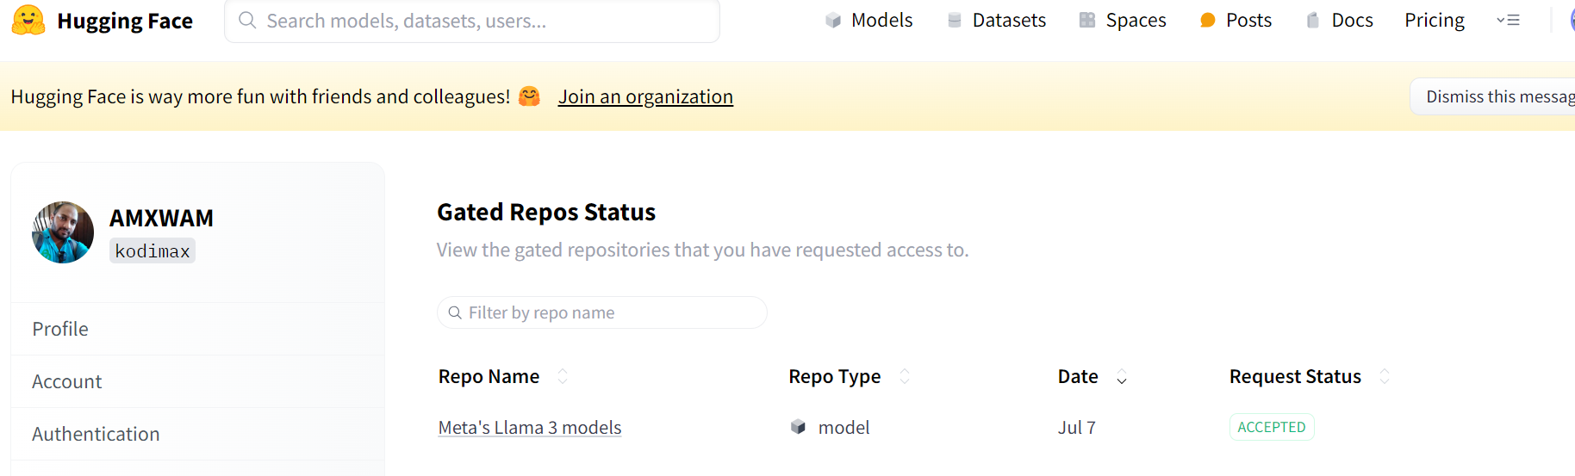
Finally gated model is ready
The size of the llama3 8b model 15-16gb . that’s why we can work with gpu.
10- login to hugging face access the token from setting - access token- create token
11- create requirement.txt file in colab because this library reduce the 15gb code to smaller !pip install -r requirement.txt
accelerate ==0.29.3 https://pypi.org/project/accelerator/
bitsandbytes https://pypi.org/project/bitsandbytes/ (bitsandbytes==0.43.1)
transformers https://pypi.org/project/transformers/ (transformers 4.42.4)
12- create config.json {"HF_TOKEN" : "enter your hf token" }
13- load model from meta - llama 3b ( copy & save
model_name = 'meta-llama/Meta-Llama-3-8B'
14- finally prompt is getting ready
=======================================================
BUILD LLAMA3 MODEL LOCALLY USING VS CODE
1- open vs code create an folder
2- create an environment variable calla llama3 cd to specific folder python -m venv llama3 .\llama3\Scripts\activate
3- create requirement.txt with( langchain, langchain_community, streamlit)
4- https://ollama.com/ model section download the models
5- ollama pull llama3 ( all model will be downloaded to vs code)
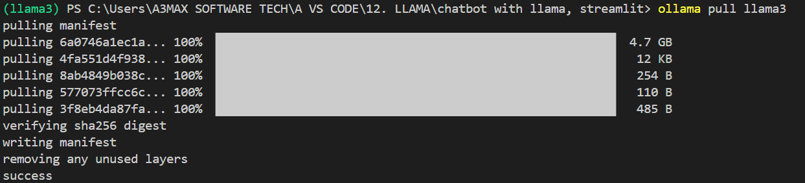
6- finally run app.py

Code explanation
• AutoTokenizer:
- Purpose: Automatically selects the correct tokenizer class for a given pre-trained model.
- Usage: It simplifies the process of loading a tokenizer, which is responsible for converting text into token IDs that the model can understand and vice versa.
- Example: AutoTokenizer.from_pretrained('gpt2') will load the appropriate tokenizer for the GPT-2 model.
• AutoModelForCausalLM:
- Purpose: Automatically selects the correct model class for causal language modeling for a given pre-trained model.
- Usage: It is used to load models that are specifically designed for tasks like text generation.
- Example: AutoModelForCausalLM.from_pretrained('gpt2') will load the GPT-2 model configured for text generation tasks.
• BitsAndBytesConfig:
- Purpose: Provides configuration settings for quantization and optimization, allowing models to be loaded in a more memory-efficient way.
- Usage: It is used to specify settings such as loading the model in 8-bit precision, which can significantly reduce memory usage and potentially speed up inference.
- Example: BitsAndBytesConfig(load_in_8bit=True) configures the model to be loaded with 8-bit precision.
• pipeline:
- Purpose: Provides a high-level API for using models in a simple and standardized way.
- Usage: It abstracts away the complexities of model inference and allows you to perform various tasks (e.g., text generation, sentiment analysis) with minimal code.
- Example: pipeline('text-generation', model=model, tokenizer=tokenizer) creates a text generation pipeline using the specified model and tokenizer.
• load_in_4bit:
- Purpose: Specifies that the model should be loaded using 4-bit precision.
- Usage: Reduces the memory footprint significantly compared to the standard 32-bit or even 8-bit precision.
- Example: load_in_4bit=True enables 4-bit quantization.
• bnb_4bit_use_double_quant:
- Purpose: Uses double quantization, which involves an additional step to further reduce the precision and memory usage while maintaining accuracy.
- Usage: Helps to improve the efficiency of the 4-bit quantization.
- Example: bnb_4bit_use_double_quant=True enables double quantization.
• bnb_4bit_quant_type:
- Purpose: Specifies the type of quantization to be used. In this case, "nf4" stands for Normal Float 4.
- Usage: Determines the specific method of 4-bit quantization.
- Example: bnb_4bit_quant_type="nf4" sets the quantization type to Normal Float 4.
• bnb_4bit_compute_dtype:
- Purpose: Specifies the data type to be used for computation. torch.bfloat16 is a 16-bit floating point data type.
- Usage: Allows for reduced memory usage during computations while preserving a good balance between precision and performance.
- Example: bnb_4bit_compute_dtype=torch.bfloat16 sets the computation to use the bfloat16 data type.

